Lab 4: Performance Lab

1 Introduction

The assembly language in Lab 3 is one of the most effective means for gaining an understanding how the code will run in high performance. In this lab, students should optimize the performance of an application kernel function such as convolution or matrix transposition. It provides a clear demonstration of the properties of cache memories and gives them experience with low-level program optimization.

2 Type

This is a team project (up to three students) which will be completed in two weeks.

3 Instructions

3.1 Image processing problem

This lab deals with optimizing memory intensive code. Image processing offers many examples of functions that can benefit from optimization. In this lab, we will consider two image processing operations: rotate, which rotates an image counter-clockwise by 90。, and smooth, which “smooths” or “blurs” an image.

For this lab, we will consider an image to be represented as a two-dimensional matrix M, where M_{i,j} denotes the value of (i, j)th pixel of M. Pixel values are triples of red, green, and blue (RGB) values. We will only consider square images. Let N denote the number of rows (or columns) of an image. Rows and columns are numbered, in C-style, from 0 to N-1.

Given this representation, the rotate operation can be implemented quite simply as the combination of the following two matrix operations:

• Transpose: For each (i, j) pair, M_{i,j} and M_{j,i} are interchanged.

• Exchange rows: Row i is exchanged with row N-1-i.

This combination is illustrated in Figure 1.

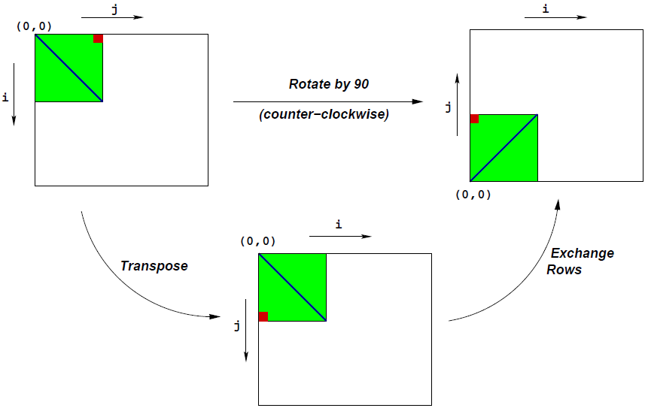
Figure 1 Rotation of an image by 90。counterclockwise

The smooth operation is implemented by replacing every pixel value with the average of all the pixels around it (in a maximum of 3×3 window centered at that pixel). Consider Figure 2. The values of pixels M2[1][1] and M2[N-1][N-1] are given below:

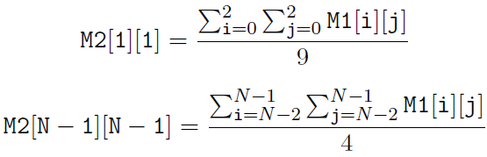

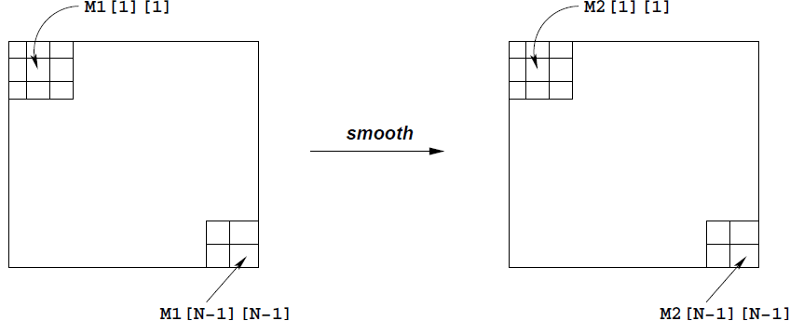

Figure 2 Smoothing an image

3.2 Source code

The only file you will be modifying is kernels.c. Looking at the file kernels.c, you’ll notice a C structure team into which you should insert the requested identifying information about the one or two individuals comprising your programming team.

3.3 Data structures

The core data structure deals with image representation. A pixel is a struct as shown below:

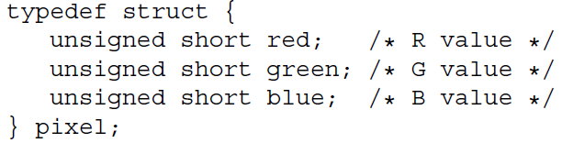

As can be seen, RGB values have 16-bit representations (“16-bit color”). An image I is represented as a one-dimensional array of pixels, where the (i, j)th pixel is I[RIDX(i,j,n)]. Here n is the dimension of the image matrix, and RIDX is a macro defined as follows:

#define RIDX(i,j,n) ((i)*(n)+(j))

See the file defs.h for this code.

3.4 Rotate operation

The following C function computes the result of rotating the source image src by 90◦ and stores the result in destination image dst. dim is the dimension of the image.

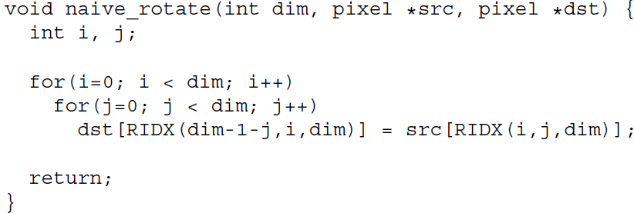

The above code scans the rows of the source image matrix, copying to the columns of the destination image matrix. Your task is to discuss the reasons of performance improvement from the functions rotate_c、rotate_b8、rotate_b4、rotate_b16_u2、rotate_b32_u2、rotate_b8_u4_c、rotate_b8_u4、rotate_b16_u4、rotate_b16_u4_c、rotate_b32_u4、rotate_b32_u4_c.

See the file kernels.c for this code.

3.5 Smooth operation

The smoothing function takes as input a source image src and returns the smoothed result in the destination image dst. Here is part of an implementation:

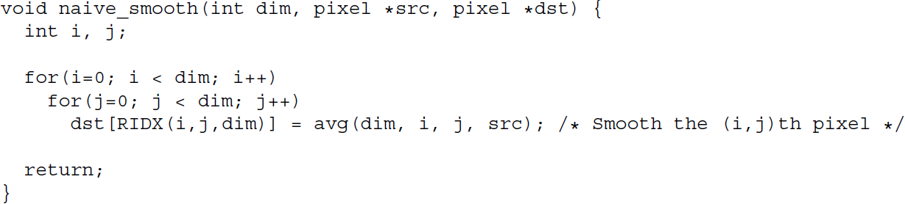

The function avg returns the average of all the pixels around the (i,j)th pixel. Your task is to optimize smooth (and avg) to run as fast as possible.

This code (and an implementation of avg) is in the file kernels.c.
Your task is to discuss the reasons of performance improvement.

3.6 Performance measures

Our main performance measure is CPE (Cycles per Element). If a function takes C cycles to run for an image of size N×N, the CPE value is C/N². Performance is shown for 5 different values of N.

The ratios (speedups) of the optimized implementation over the naive one will constitute a score of your implementation. To summarize the overall effect over different values of N, we will compute the geometric mean of the results for these 5 values. That is, if the measured speedups for N = {32, 64, 128, 256, 512} are R₃₂, R₆₄, R₁₂₈, R₂₅₆, and R₅₁₂ then we compute the overall performance as

3.7 Running

The source code you will write will be linked with object code that we supply into a driver binary. To create this binary, you will need to execute the command

unix> make driver

You will need to re-make driver each time you change the code in kernels.c. To test your implementations, you can then run the command:

unix> ./driver

4 Handin
For rotating:

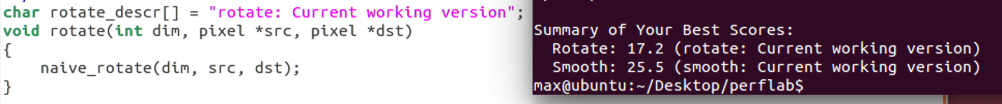

Above is the original naive rotate, for the context.
After switching columns and rows, the performance was enhanced. In this lab, values are read in column order, meaning one column is loaded into cache at a time. Thus, reading reading columns first enjoys better spatial locality.
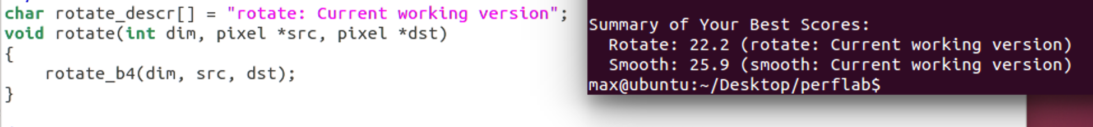

Loop tiling by 4 is slower than tiling by 8, because tiling by 8 makes better use of cache (L1 cache can hold more than 8).

Unrolling the loop by 4*4 decreased the performance.

Based on tiling by 8 and unrolling by 4*4, to read data column-wise has better performance because it enjoys better spatial locality.

Tiling by the same block, unrolling by 4 is slower than 2.

Tiling by 32 is slower than 16.

Unrolling by 4 is slower than 2.

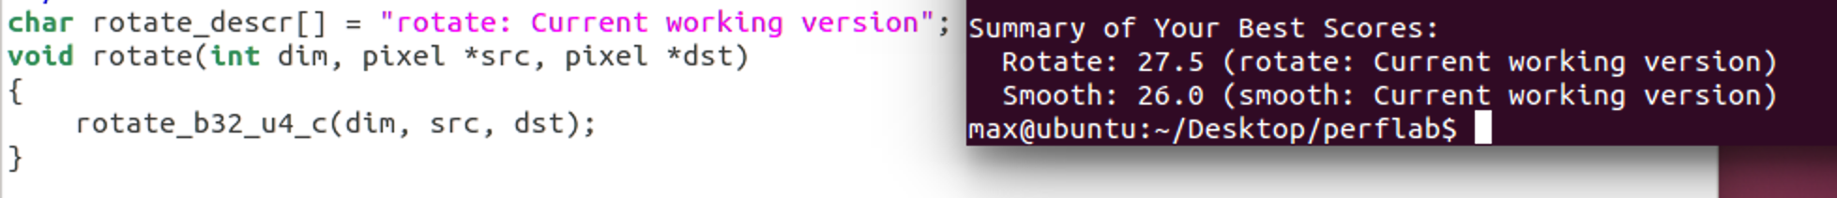
It will have better performance if given better spatial locality.
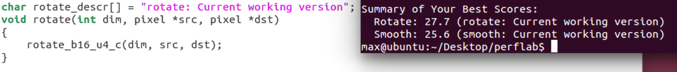
Performance is even better if tiling by 16.

For smoothing:
We store the min and max function called in the for loop in two temporary variable outside and instead of using RIDX with macro, we calculate the value directly. Because we reduce the macro call and the function reference, so the performance is improved. 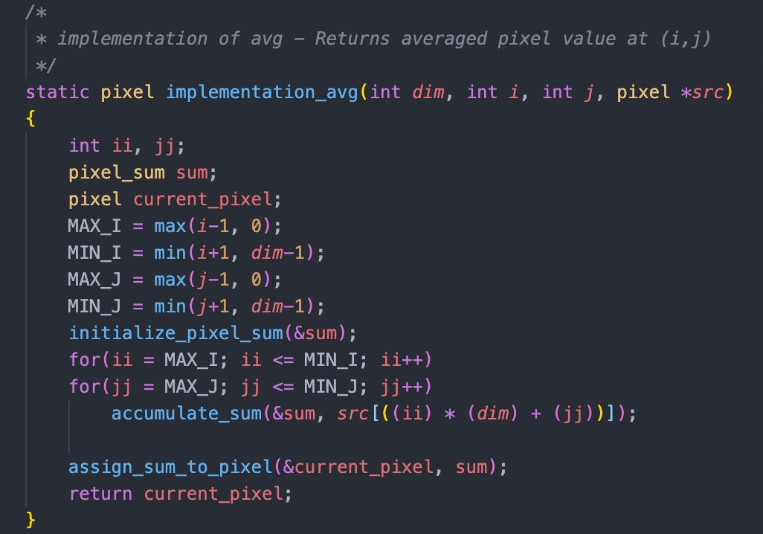
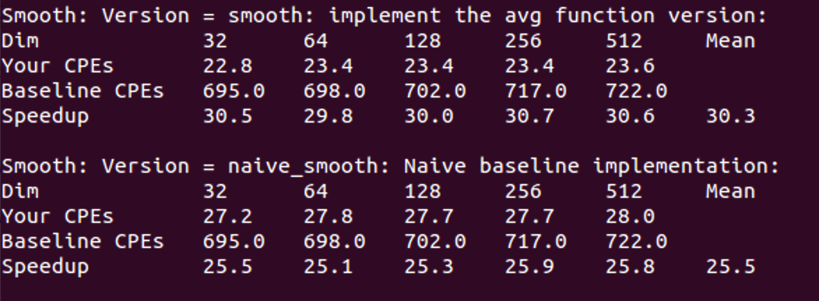
For the smooth performance improvement, since we store the value in a table when we do smooth for lows, so when we do smooth for columns, we can use the value store in the table.
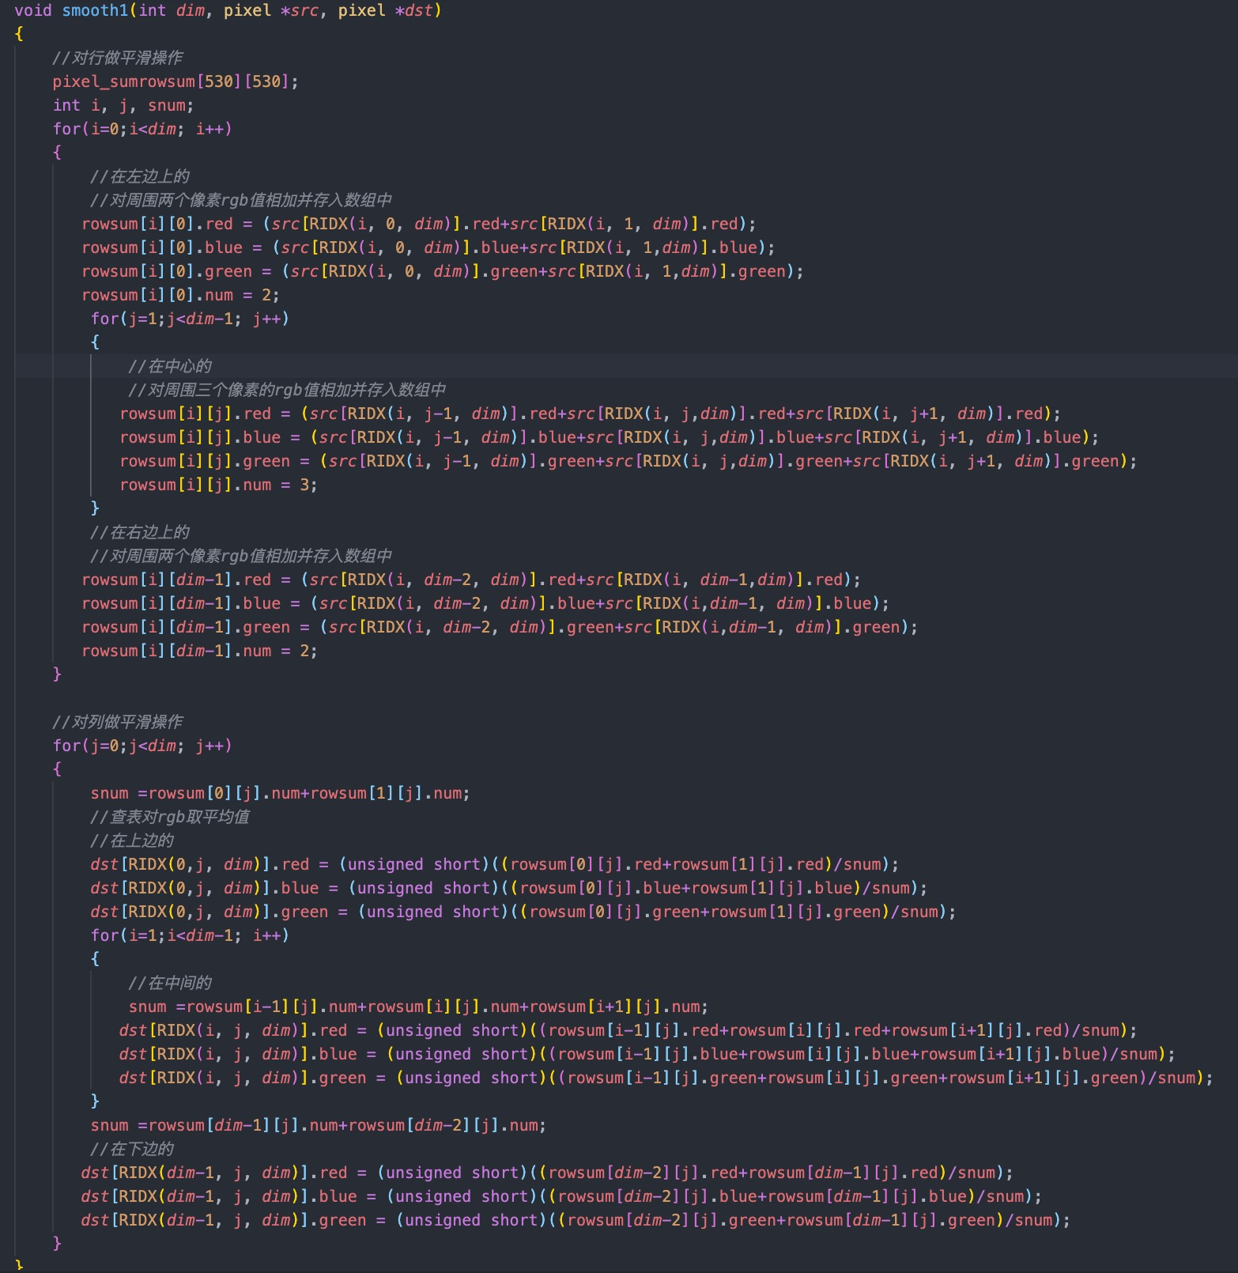
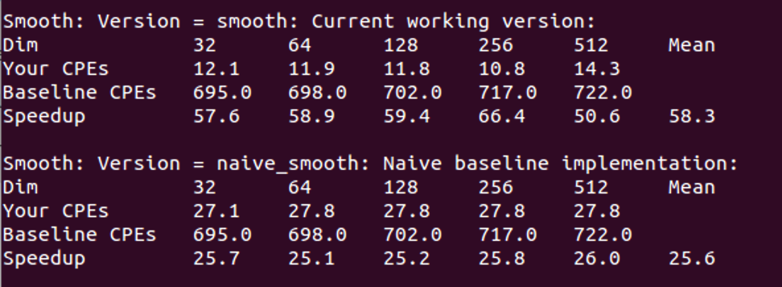

The code implementing smoothing:
static pixel implementation_avg(int dim, int i, int j, pixel *src)
{
int ii, jj, MAX_I, MIN_I, MAX_J, MIN_J;
pixel_sum sum;
pixel current_pixel;
MAX_I = max(i-1, 0);
MIN_I = min(i+1, dim-1);
MAX_J = max(j-1, 0);
MIN_J = min(j+1, dim-1);
initialize_pixel_sum(&sum);
for(ii = MAX_I; ii <= MIN_I; ii++)
for(jj = MAX_J; jj <= MIN_J; jj++)
accumulate_sum(&sum, src[((ii) * (dim) + (jj))]);
assign_sum_to_pixel(&current_pixel, sum);
return current_pixel;
}

void smooth1(int dim, pixel *src, pixel *dst)
{
pixel_sum rowsum[530][530];
int i, j, snum;
for(i=0;i<dim; i++)
{
rowsum[i][0].red = (src[RIDX(i, 0, dim)].red+src[RIDX(i, 1, dim)].red);
rowsum[i][0].blue = (src[RIDX(i, 0, dim)].blue+src[RIDX(i, 1,dim)].blue);
rowsum[i][0].green = (src[RIDX(i, 0, dim)].green+src[RIDX(i, 1,dim)].green);
rowsum[i][0].num = 2;
for(j=1;j<dim-1; j++)
{
rowsum[i][j].red = (src[RIDX(i, j-1, dim)].red+src[RIDX(i, j,dim)].red+src[RIDX(i, j+1, dim)].red);
rowsum[i][j].blue = (src[RIDX(i, j-1, dim)].blue+src[RIDX(i, j,dim)].blue+src[RIDX(i, j+1, dim)].blue);
rowsum[i][j].green = (src[RIDX(i, j-1, dim)].green+src[RIDX(i, j,dim)].green+src[RIDX(i, j+1, dim)].green);
rowsum[i][j].num = 3;
}
rowsum[i][dim-1].red = (src[RIDX(i, dim-2, dim)].red+src[RIDX(i, dim-1,dim)].red);
rowsum[i][dim-1].blue = (src[RIDX(i, dim-2, dim)].blue+src[RIDX(i,dim-1, dim)].blue);
rowsum[i][dim-1].green = (src[RIDX(i, dim-2, dim)].green+src[RIDX(i,dim-1, dim)].green);
rowsum[i][dim-1].num = 2;
}
for(j=0;j<dim; j++)
{
snum =rowsum[0][j].num+rowsum[1][j].num;
dst[RIDX(0,j, dim)].red = (unsigned short)((rowsum[0][j].red+rowsum[1][j].red)/snum);
dst[RIDX(0,j, dim)].blue = (unsigned short)((rowsum[0][j].blue+rowsum[1][j].blue)/snum);
dst[RIDX(0,j, dim)].green = (unsigned short)((rowsum[0][j].green+rowsum[1][j].green)/snum);
for(i=1;i<dim-1; i++)
{
snum =rowsum[i-1][j].num+rowsum[i][j].num+rowsum[i+1][j].num;
dst[RIDX(i, j, dim)].red = (unsigned short)((rowsum[i-1][j].red+rowsum[i][j].red+rowsum[i+1][j].red)/snum);
dst[RIDX(i, j, dim)].blue = (unsigned short)((rowsum[i-1][j].blue+rowsum[i][j].blue+rowsum[i+1][j].blue)/snum);
dst[RIDX(i, j, dim)].green = (unsigned short)((rowsum[i-1][j].green+rowsum[i][j].green+rowsum[i+1][j].green)/snum);
}
snum =rowsum[dim-1][j].num+rowsum[dim-2][j].num;
dst[RIDX(dim-1, j, dim)].red = (unsigned short)((rowsum[dim-2][j].red+rowsum[dim-1][j].red)/snum);
dst[RIDX(dim-1, j, dim)].blue = (unsigned short)((rowsum[dim-2][j].blue+rowsum[dim-1][j].blue)/snum);
dst[RIDX(dim-1, j, dim)].green = (unsigned short)((rowsum[dim-2][j].green+rowsum[dim-1][j].green)/snum);
}
}

The code implementing rotation:
void rotate_c(int dim, pixel *src, pixel *dst)
{
int i, j;

for (j = 0; j < dim; j++)
for (i = 0; i < dim; i++)
dst[RIDX(dim-1-j, i, dim)] = src[RIDX(i, j, dim)];
}

void rotate_b8(int dim, pixel *src, pixel *dst)
{
int i, j, k, h;
for (k = 0; k < dim; k += 8){
for (h = 0; h < dim; h += 8) {
for (i = k; i < k + 8; i++){
for (j = h; j < h + 8; j++)
dst[RIDX(dim-1-j, i, dim)] = src[RIDX(i, j, dim)];
}
}
}
}

void rotate_b4(int dim, pixel *src, pixel *dst)
{
int i, j, k, h;
for (k = 0; k < dim; k += 4){
for (h = 0; h < dim; h += 4) {
for (i = k; i < k + 4; i++){
for (j = h; j < h + 4; j++)
dst[RIDX(dim-1-j, i, dim)] = src[RIDX(i, j, dim)];
}
}
}
}

void rotate_b16_u2(int dim, pixel *src, pixel *dst)
{
int i, j, k, h;
for (k = 0; k < dim; k += 16){
for (h = 0; h < dim; h += 16) {
for (i = k; i < k + 16; i += 2){
for (j = h; j < h + 16; j += 2){
dst[RIDX(dim-1-j, i, dim)] = src[RIDX(i, j, dim)];
dst[RIDX(dim-1-j-1, i, dim)] = src[RIDX(i, j + 1, dim)];
dst[RIDX(dim-1-j, i + 1, dim)] = src[RIDX(i + 1, j, dim)];
dst[RIDX(dim-1-j-1, i + 1, dim)] = src[RIDX(i + 1, j + 1, dim)];
}
}
}
}
}

void rotate_b32_u2(int dim, pixel *src, pixel *dst)
{
int i, j, k, h;
for (k = 0; k < dim; k += 32){
for (h = 0; h < dim; h += 32) {
for (i = k; i < k + 32; i += 2){
for (j = h; j < h + 32; j += 2){
dst[RIDX(dim-1-j, i, dim)] = src[RIDX(i, j, dim)];
dst[RIDX(dim-1-j-1, i, dim)] = src[RIDX(i, j + 1, dim)];
dst[RIDX(dim-1-j, i + 1, dim)] = src[RIDX(i + 1, j, dim)];
dst[RIDX(dim-1-j-1, i + 1, dim)] = src[RIDX(i + 1, j + 1, dim)];
}
}
}
}
}

void rotate_b8_u4(int dim, pixel *src, pixel *dst)
{
int i, j, k, h;
for (k = 0; k < dim; k += 8){
for (h = 0; h < dim; h += 8) {
for (i = k; i < k + 8; i += 4){
for (j = h; j < h + 8; j += 4){
dst[RIDX(dim-1-j, i, dim)] = src[RIDX(i, j, dim)];
dst[RIDX(dim-1-j-1, i, dim)] = src[RIDX(i, j + 1, dim)];
dst[RIDX(dim-1-j-2, i, dim)] = src[RIDX(i, j + 2, dim)];
dst[RIDX(dim-1-j-3, i, dim)] = src[RIDX(i, j + 3, dim)];

dst[RIDX(dim-1-j, i + 1, dim)] = src[RIDX(i + 1, j, dim)];
dst[RIDX(dim-1-j-1, i + 1, dim)] = src[RIDX(i + 1, j + 1, dim)];
dst[RIDX(dim-1-j-2, i + 1, dim)] = src[RIDX(i + 1, j + 2, dim)];
dst[RIDX(dim-1-j-3, i + 1, dim)] = src[RIDX(i + 1, j + 3, dim)];

dst[RIDX(dim-1-j, i + 2, dim)] = src[RIDX(i + 2, j, dim)];
dst[RIDX(dim-1-j-1, i + 2, dim)] = src[RIDX(i + 2, j + 1, dim)];
dst[RIDX(dim-1-j-2, i + 2, dim)] = src[RIDX(i + 2, j + 2, dim)];
dst[RIDX(dim-1-j-3, i + 2, dim)] = src[RIDX(i + 2, j + 3, dim)];

dst[RIDX(dim-1-j, i + 3, dim)] = src[RIDX(i + 3, j, dim)];
dst[RIDX(dim-1-j-1, i + 3, dim)] = src[RIDX(i + 3, j + 1, dim)];
dst[RIDX(dim-1-j-2, i + 3, dim)] = src[RIDX(i + 3, j + 2, dim)];
dst[RIDX(dim-1-j-3, i + 3, dim)] = src[RIDX(i + 3, j + 3, dim)];

}
}
}
}
}

void rotate_b8_u4_c(int dim, pixel *src, pixel *dst)
{
int i, j, k, h;
for (k = 0; k < dim; k += 8){
for (h = 0; h < dim; h += 8) {
for (j = k; j < k + 8; j += 4){
for (i = h; i < h + 8; i += 4){
dst[RIDX(dim-1-j, i, dim)] = src[RIDX(i, j, dim)];
dst[RIDX(dim-1-j-1, i, dim)] = src[RIDX(i, j + 1, dim)];
dst[RIDX(dim-1-j-2, i, dim)] = src[RIDX(i, j + 2, dim)];
dst[RIDX(dim-1-j-3, i, dim)] = src[RIDX(i, j + 3, dim)];

dst[RIDX(dim-1-j, i + 1, dim)] = src[RIDX(i + 1, j, dim)];
dst[RIDX(dim-1-j-1, i + 1, dim)] = src[RIDX(i + 1, j + 1, dim)];
dst[RIDX(dim-1-j-2, i + 1, dim)] = src[RIDX(i + 1, j + 2, dim)];
dst[RIDX(dim-1-j-3, i + 1, dim)] = src[RIDX(i + 1, j + 3, dim)];

dst[RIDX(dim-1-j, i + 2, dim)] = src[RIDX(i + 2, j, dim)];
dst[RIDX(dim-1-j-1, i + 2, dim)] = src[RIDX(i + 2, j + 1, dim)];
dst[RIDX(dim-1-j-2, i + 2, dim)] = src[RIDX(i + 2, j + 2, dim)];
dst[RIDX(dim-1-j-3, i + 2, dim)] = src[RIDX(i + 2, j + 3, dim)];

dst[RIDX(dim-1-j, i + 3, dim)] = src[RIDX(i + 3, j, dim)];
dst[RIDX(dim-1-j-1, i + 3, dim)] = src[RIDX(i + 3, j + 1, dim)];
dst[RIDX(dim-1-j-2, i + 3, dim)] = src[RIDX(i + 3, j + 2, dim)];
dst[RIDX(dim-1-j-3, i + 3, dim)] = src[RIDX(i + 3, j + 3, dim)];

}
}
}
}
}

void rotate_b16_u4(int dim, pixel *src, pixel *dst)
{
int i, j, k, h;
for (k = 0; k < dim; k += 16){
for (h = 0; h < dim; h += 16) {
for (i = k; i < k + 16; i += 4){
for (j = h; j < h + 16; j += 4){
dst[RIDX(dim-1-j, i, dim)] = src[RIDX(i, j, dim)];
dst[RIDX(dim-1-j-1, i, dim)] = src[RIDX(i, j + 1, dim)];
dst[RIDX(dim-1-j-2, i, dim)] = src[RIDX(i, j + 2, dim)];
dst[RIDX(dim-1-j-3, i, dim)] = src[RIDX(i, j + 3, dim)];

dst[RIDX(dim-1-j, i + 1, dim)] = src[RIDX(i + 1, j, dim)];
dst[RIDX(dim-1-j-1, i + 1, dim)] = src[RIDX(i + 1, j + 1, dim)];
dst[RIDX(dim-1-j-2, i + 1, dim)] = src[RIDX(i + 1, j + 2, dim)];
dst[RIDX(dim-1-j-3, i + 1, dim)] = src[RIDX(i + 1, j + 3, dim)];

dst[RIDX(dim-1-j, i + 2, dim)] = src[RIDX(i + 2, j, dim)];
dst[RIDX(dim-1-j-1, i + 2, dim)] = src[RIDX(i + 2, j + 1, dim)];
dst[RIDX(dim-1-j-2, i + 2, dim)] = src[RIDX(i + 2, j + 2, dim)];
dst[RIDX(dim-1-j-3, i + 2, dim)] = src[RIDX(i + 2, j + 3, dim)];

dst[RIDX(dim-1-j, i + 3, dim)] = src[RIDX(i + 3, j, dim)];
dst[RIDX(dim-1-j-1, i + 3, dim)] = src[RIDX(i + 3, j + 1, dim)];
dst[RIDX(dim-1-j-2, i + 3, dim)] = src[RIDX(i + 3, j + 2, dim)];
dst[RIDX(dim-1-j-3, i + 3, dim)] = src[RIDX(i + 3, j + 3, dim)];

}
}
}
}
}

void rotate_b16_u4_c(int dim, pixel *src, pixel *dst)
{
int i, j, k, h;
for (k = 0; k < dim; k += 16){
for (h = 0; h < dim; h += 16) {
for (j = k; j < k + 16; j += 4){
for (i = h; i < h + 16; i += 4){
dst[RIDX(dim-1-j, i, dim)] = src[RIDX(i, j, dim)];
dst[RIDX(dim-1-j-1, i, dim)] = src[RIDX(i, j + 1, dim)];
dst[RIDX(dim-1-j-2, i, dim)] = src[RIDX(i, j + 2, dim)];
dst[RIDX(dim-1-j-3, i, dim)] = src[RIDX(i, j + 3, dim)];

dst[RIDX(dim-1-j, i + 1, dim)] = src[RIDX(i + 1, j, dim)];
dst[RIDX(dim-1-j-1, i + 1, dim)] = src[RIDX(i + 1, j + 1, dim)];
dst[RIDX(dim-1-j-2, i + 1, dim)] = src[RIDX(i + 1, j + 2, dim)];
dst[RIDX(dim-1-j-3, i + 1, dim)] = src[RIDX(i + 1, j + 3, dim)];

dst[RIDX(dim-1-j, i + 2, dim)] = src[RIDX(i + 2, j, dim)];
dst[RIDX(dim-1-j-1, i + 2, dim)] = src[RIDX(i + 2, j + 1, dim)];
dst[RIDX(dim-1-j-2, i + 2, dim)] = src[RIDX(i + 2, j + 2, dim)];
dst[RIDX(dim-1-j-3, i + 2, dim)] = src[RIDX(i + 2, j + 3, dim)];

dst[RIDX(dim-1-j, i + 3, dim)] = src[RIDX(i + 3, j, dim)];
dst[RIDX(dim-1-j-1, i + 3, dim)] = src[RIDX(i + 3, j + 1, dim)];
dst[RIDX(dim-1-j-2, i + 3, dim)] = src[RIDX(i + 3, j + 2, dim)];
dst[RIDX(dim-1-j-3, i + 3, dim)] = src[RIDX(i + 3, j + 3, dim)];

}
}
}
}
}

void rotate_b32_u4(int dim, pixel *src, pixel *dst)
{
int i, j, k, h;
for (k = 0; k < dim; k += 32){
for (h = 0; h < dim; h += 32) {
for (i = k; i < k + 32; i += 4){
for (j = h; j < h + 32; j += 4){
dst[RIDX(dim-1-j, i, dim)] = src[RIDX(i, j, dim)];
dst[RIDX(dim-1-j-1, i, dim)] = src[RIDX(i, j + 1, dim)];
dst[RIDX(dim-1-j-2, i, dim)] = src[RIDX(i, j + 2, dim)];
dst[RIDX(dim-1-j-3, i, dim)] = src[RIDX(i, j + 3, dim)];

dst[RIDX(dim-1-j, i + 1, dim)] = src[RIDX(i + 1, j, dim)];
dst[RIDX(dim-1-j-1, i + 1, dim)] = src[RIDX(i + 1, j + 1, dim)];
dst[RIDX(dim-1-j-2, i + 1, dim)] = src[RIDX(i + 1, j + 2, dim)];
dst[RIDX(dim-1-j-3, i + 1, dim)] = src[RIDX(i + 1, j + 3, dim)];

dst[RIDX(dim-1-j, i + 2, dim)] = src[RIDX(i + 2, j, dim)];
dst[RIDX(dim-1-j-1, i + 2, dim)] = src[RIDX(i + 2, j + 1, dim)];
dst[RIDX(dim-1-j-2, i + 2, dim)] = src[RIDX(i + 2, j + 2, dim)];
dst[RIDX(dim-1-j-3, i + 2, dim)] = src[RIDX(i + 2, j + 3, dim)];

dst[RIDX(dim-1-j, i + 3, dim)] = src[RIDX(i + 3, j, dim)];
dst[RIDX(dim-1-j-1, i + 3, dim)] = src[RIDX(i + 3, j + 1, dim)];
dst[RIDX(dim-1-j-2, i + 3, dim)] = src[RIDX(i + 3, j + 2, dim)];
dst[RIDX(dim-1-j-3, i + 3, dim)] = src[RIDX(i + 3, j + 3, dim)];
}
}
}
}
}

void rotate_b32_u4_c(int dim, pixel *src, pixel *dst)
{
int i, j, k, h;
for (k = 0; k < dim; k += 32){
for (h = 0; h < dim; h += 32) {
for (j = k; j < k + 32; j += 4){
for (i = h; i < h + 32; i += 4){
dst[RIDX(dim-1-j, i, dim)] = src[RIDX(i, j, dim)];
dst[RIDX(dim-1-j-1, i, dim)] = src[RIDX(i, j + 1, dim)];
dst[RIDX(dim-1-j-2, i, dim)] = src[RIDX(i, j + 2, dim)];
dst[RIDX(dim-1-j-3, i, dim)] = src[RIDX(i, j + 3, dim)];

dst[RIDX(dim-1-j, i + 1, dim)] = src[RIDX(i + 1, j, dim)];
dst[RIDX(dim-1-j-1, i + 1, dim)] = src[RIDX(i + 1, j + 1, dim)];
dst[RIDX(dim-1-j-2, i + 1, dim)] = src[RIDX(i + 1, j + 2, dim)];
dst[RIDX(dim-1-j-3, i + 1, dim)] = src[RIDX(i + 1, j + 3, dim)];

dst[RIDX(dim-1-j, i + 2, dim)] = src[RIDX(i + 2, j, dim)];
dst[RIDX(dim-1-j-1, i + 2, dim)] = src[RIDX(i + 2, j + 1, dim)];
dst[RIDX(dim-1-j-2, i + 2, dim)] = src[RIDX(i + 2, j + 2, dim)];
dst[RIDX(dim-1-j-3, i + 2, dim)] = src[RIDX(i + 2, j + 3, dim)];

dst[RIDX(dim-1-j, i + 3, dim)] = src[RIDX(i + 3, j, dim)];
dst[RIDX(dim-1-j-1, i + 3, dim)] = src[RIDX(i + 3, j + 1, dim)];
dst[RIDX(dim-1-j-2, i + 3, dim)] = src[RIDX(i + 3, j + 2, dim)];
dst[RIDX(dim-1-j-3, i + 3, dim)] = src[RIDX(i + 3, j + 3, dim)];
}
}
}
}
}

